**Creating a router on Ubuntu 18.04**

**The first step** to create a route is to make sure you have two network interface cards (NIC) in your PC. To reach the screen settings for your NICs, press your windows key and search network.

NIC one should be set like this:

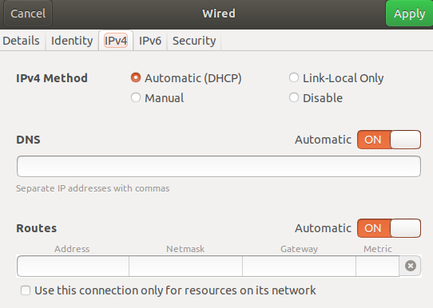

NIC two should be set like this:

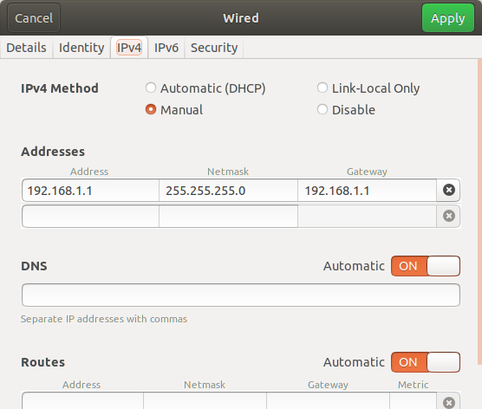

**The second step**.. Open up the terminal (ctrl+alt+t), type in the command below to install the software to make a DHCP server



**The third step** is to make sure you select the correct NIC to utilize Dynamic Host Configuration Protocol (dhcp):

Enter nano -w /etc/default/isc-dhcp-server



This will put you on the following screen:

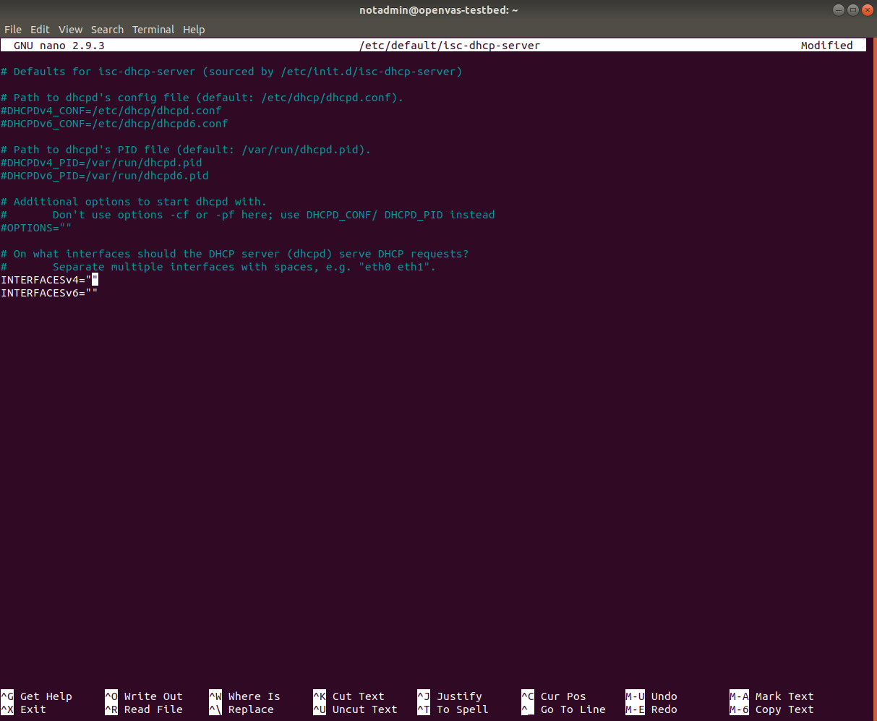

Uncomment the following lines by removing the #:

DHCPDv4_PID=/var/run/dhcpd.pid

DHCPDv4_CONF=/etc/dhcp/dhcpd.conf

Next navigate to the Line INTERFACESv4=”” insert the desired NIC name.

For the current router we will be using INTERFACESv4="enp2s0"

Next navigate to the Line INTERFACESv6=”” insert the desired NIC name.

For the current router we will be using INTERFACESv6="enp2s0"

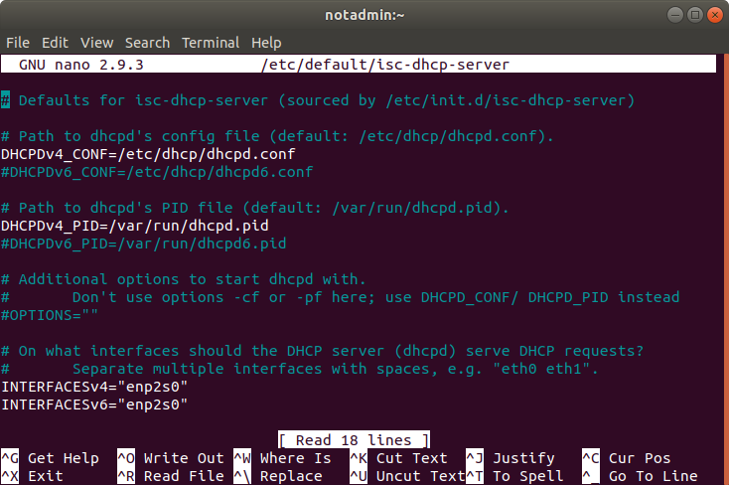

Then save by pressing **ctrl+x, y, enter** (in that exact order).

**The fourth step**.. you must set up a DHCP server on your device.

Start by changing the DHCP config file.



This should get you to a page like below.

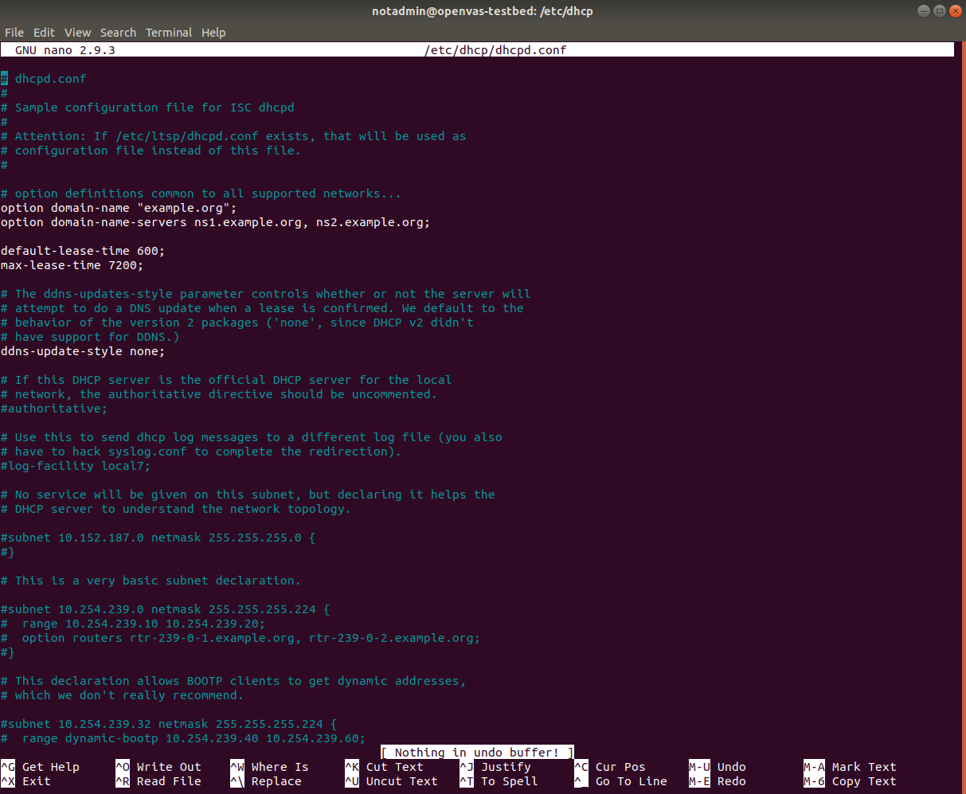

Uncomment the following line by removing the #:

authoritative;

Then make the following changes below the authoritative line:

subnet 192.168.1.0 netmask 255.255.255.0 {

range 192.168.1.100 192.168.1.200;

option subnet-mask 255.255.255.0;

option routers 192.168.1.1;

option broadcast-address 192.168.1.255;

default-lease-time 600;

max-lease-time 7200;

}

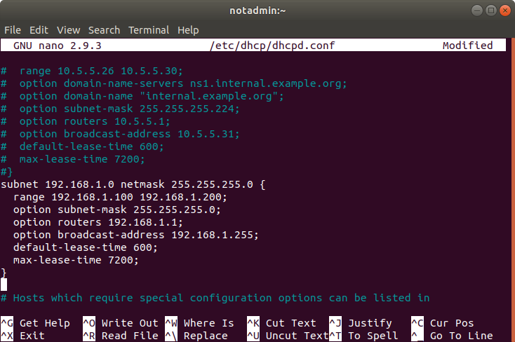

Then save by pressing **ctrl+x, y, enter**.

**The fifth step.**. Start your DHCP server:

In the terminal, Type in **sudo systemctl start isc-dhcp-server.service**



This will start the dhcp server

Type in **sudo systemctl enable isc-dhcp-server.service**



This will start dhcp on restart of the computer